**Creating First Project**

**Pre-Requisites:**

Install MPLAB latest version.

Install MPLAB Harmony Configurator.

Install XC32 compiler.

Step 1: Open MPLAB IDE ->File -> New Project.

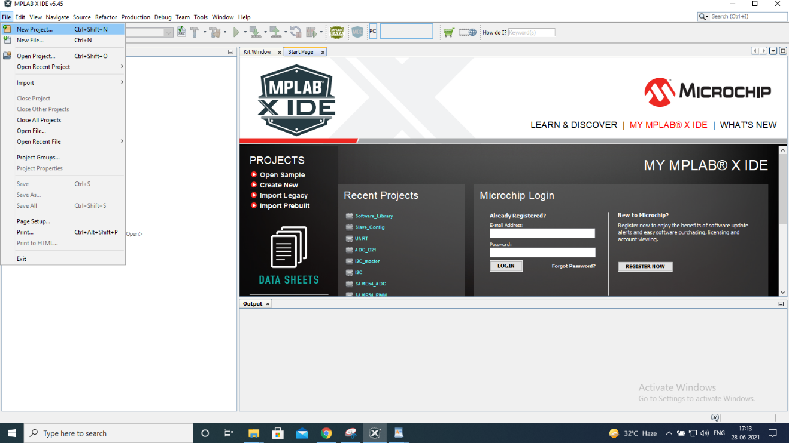

Step 2: Select 32 bit MPLAb Harmony 3 project and click on Next Button.

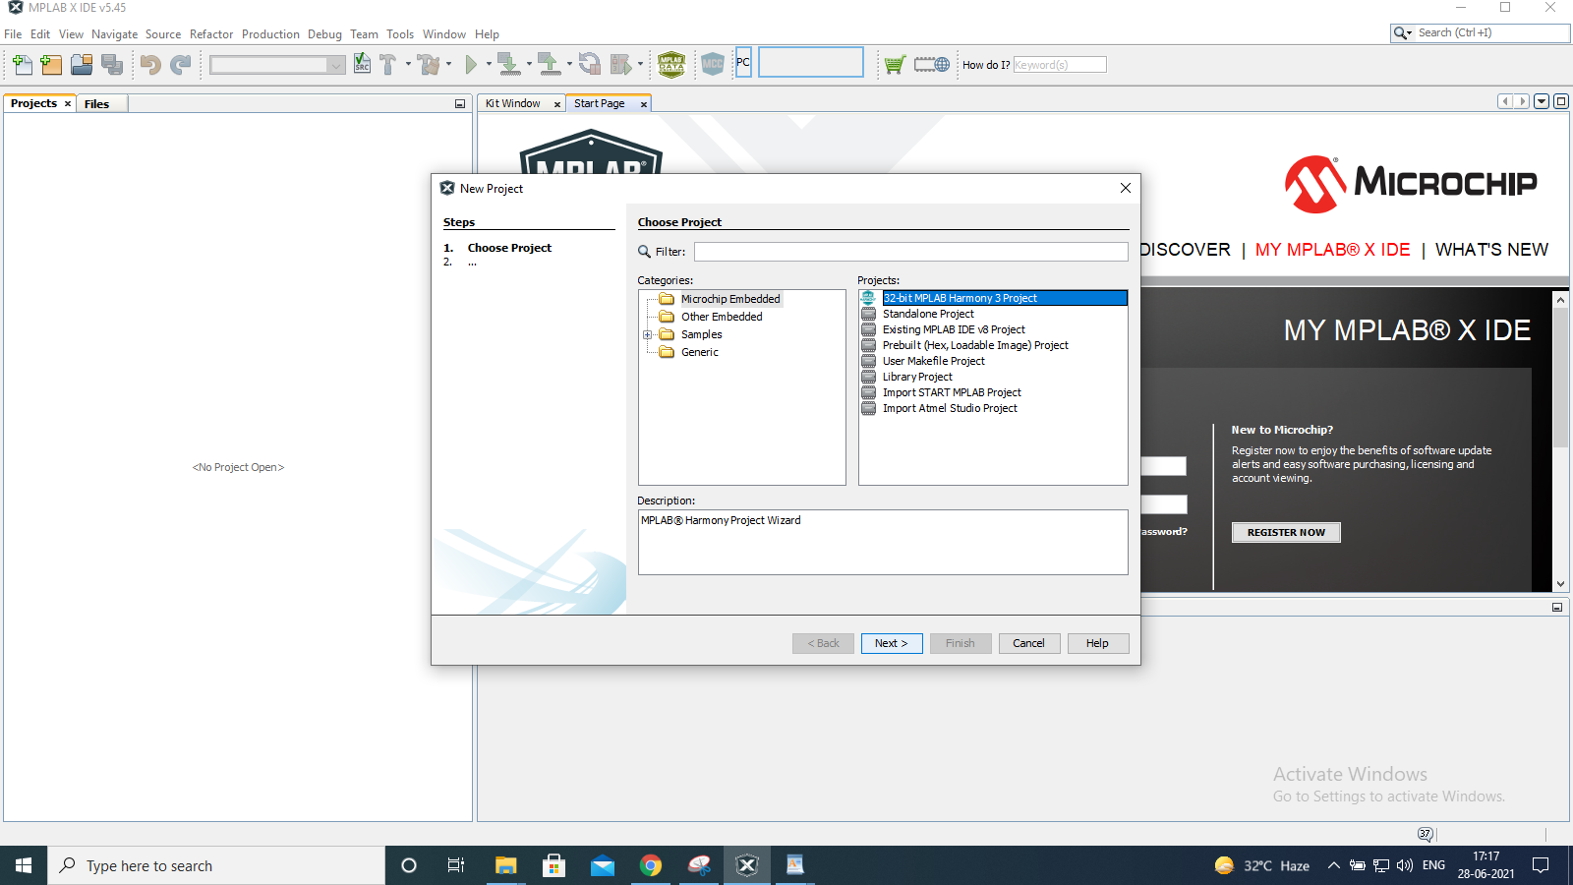

Step 3: Click on Next if MHC packages are already installed from the MPLAB content manager

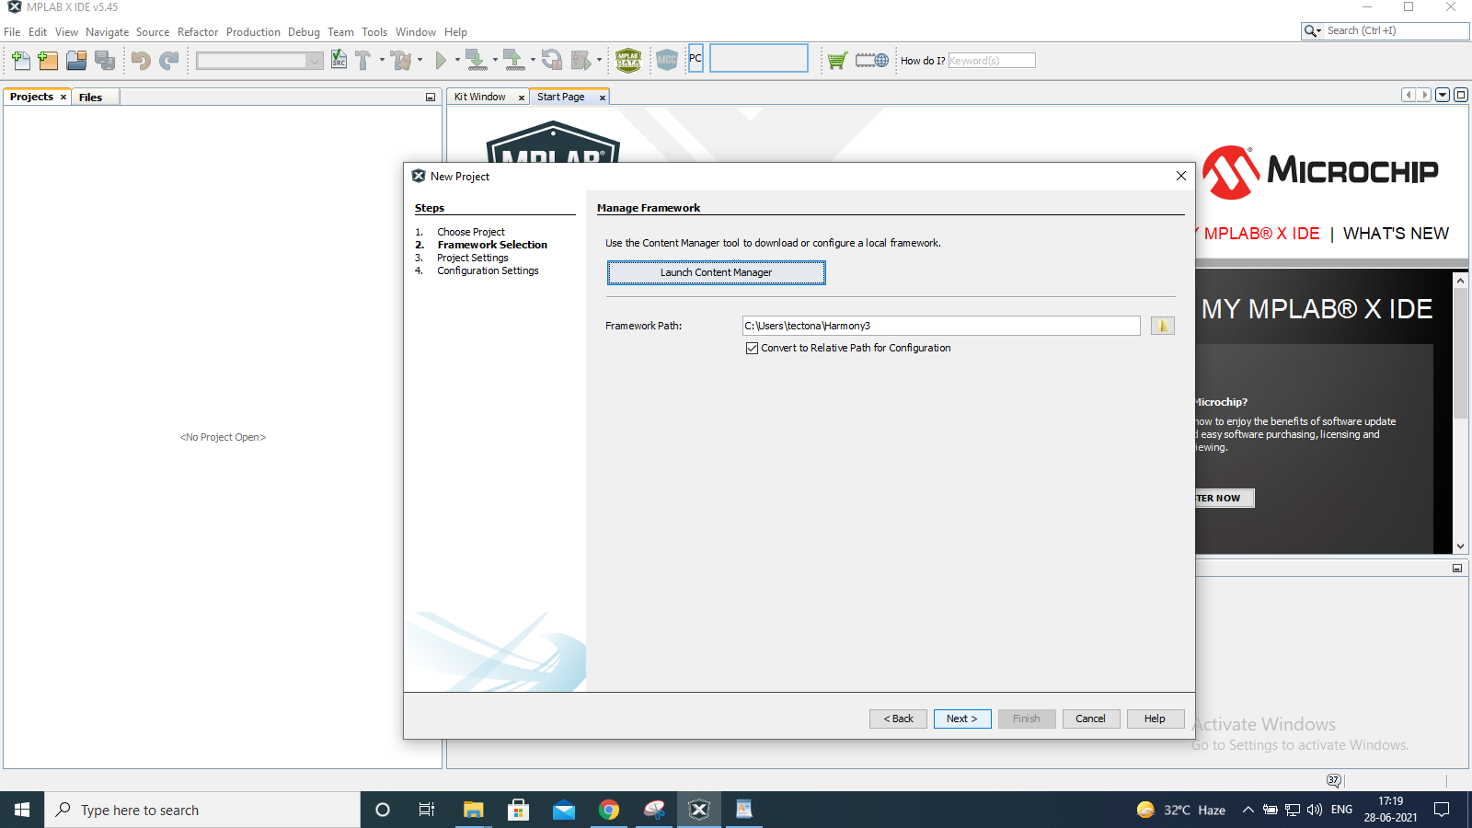

Step 4: Enter location and relevant project name and click on Next button.

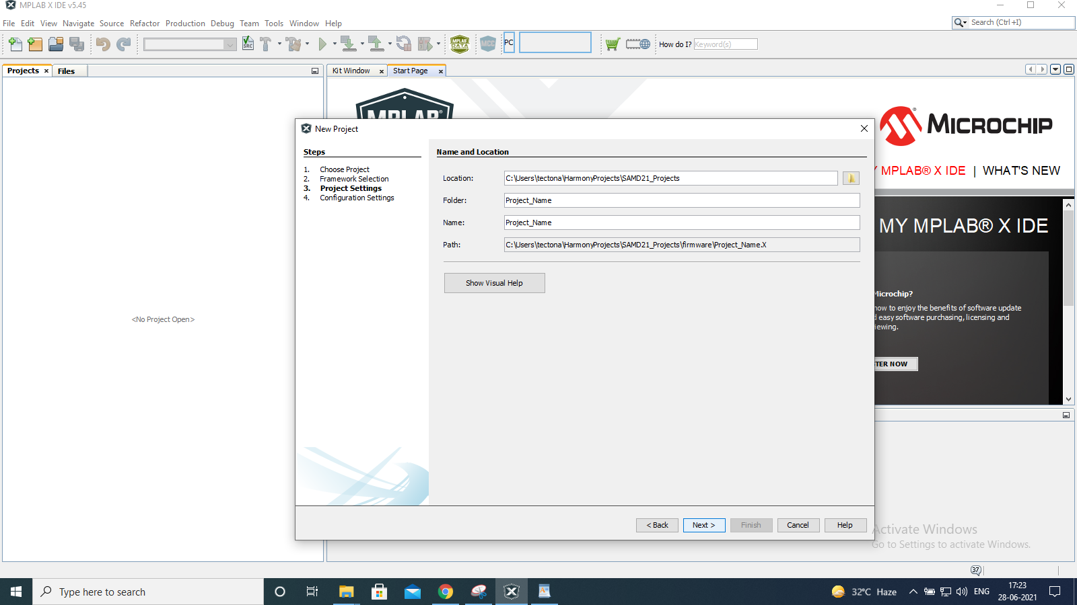

Step 5: Select target device ATSAMD21G17D and click on Finish button, your first project is created, you can see your project in project tab on the left side of MPLAB IDE.

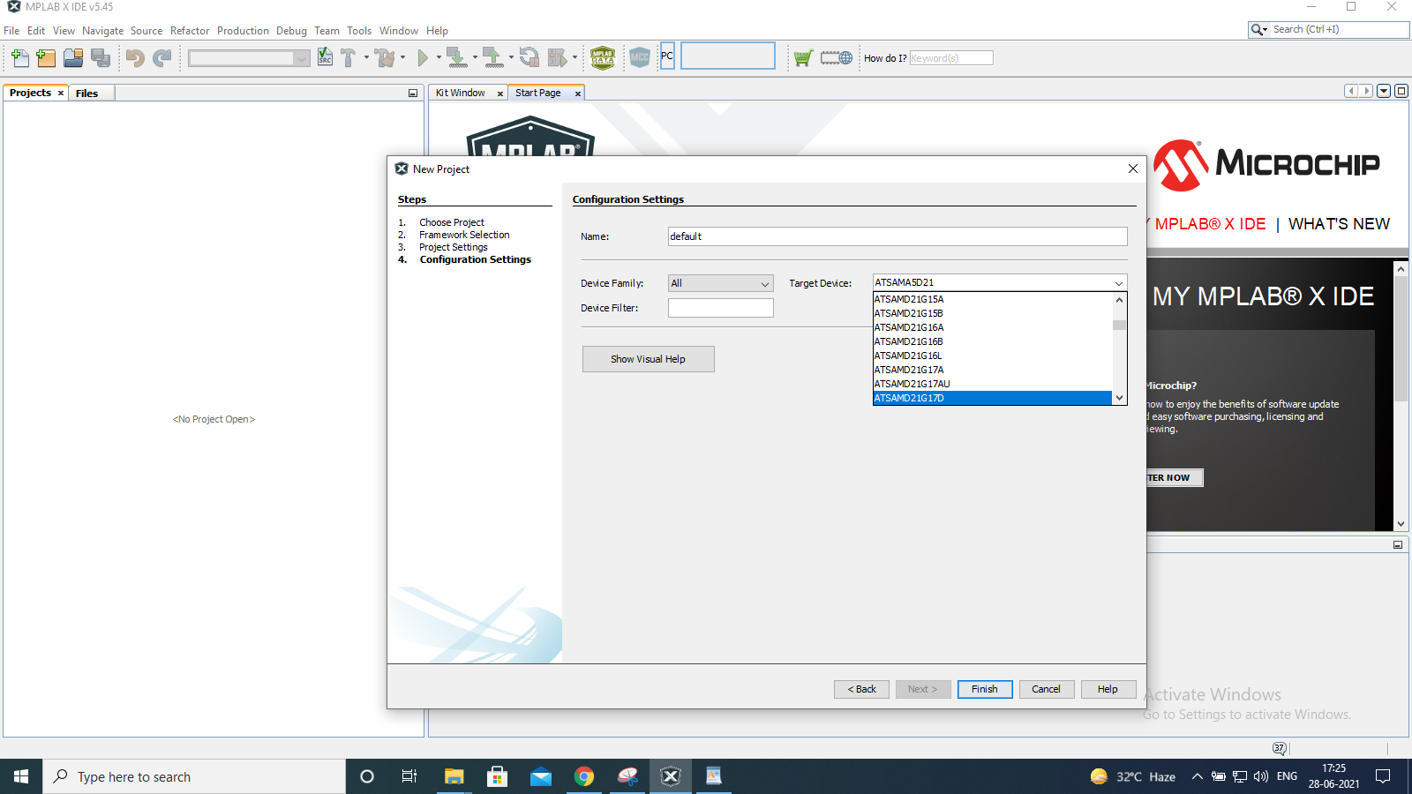

Step 6: You can see your project dashboard on the left bottom, click on project properties on top left of the dashboard window.

Project properties window will open click on "conf"

1) Check the device "ATSAMD21G17D" is connected to your laptop or PC, the board will detect automatically,

2) Select Sam D21 curiosity Nano board on connected Hardware Tool,

3) Select Compiler Toolchain XC32 as shown in figure below.

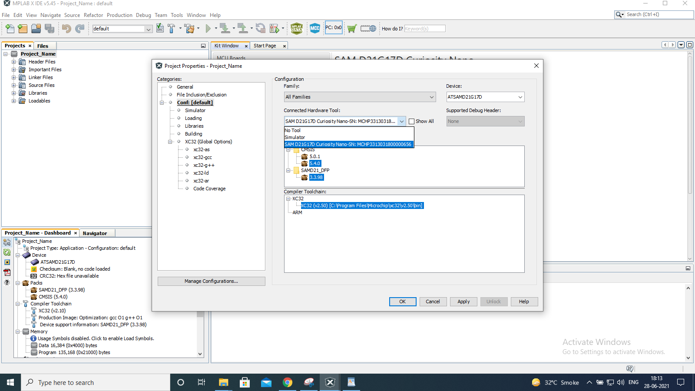

**Your first project is ready.**

Step 7: Open MPLAB harmony configurator from Tools->Embedded->MPLAB Harmony 3 Configurator.

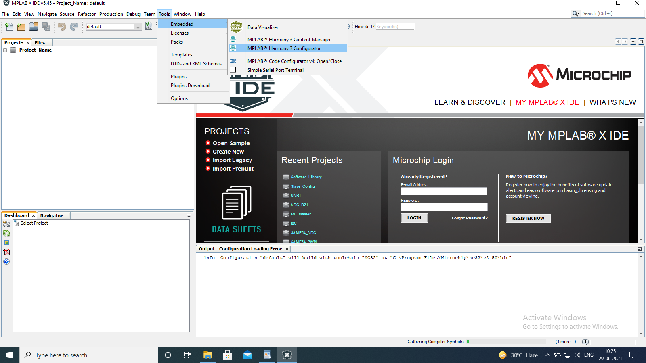

Step 8: Select MPLAB Harmony project, don't change default path then Click on Launch

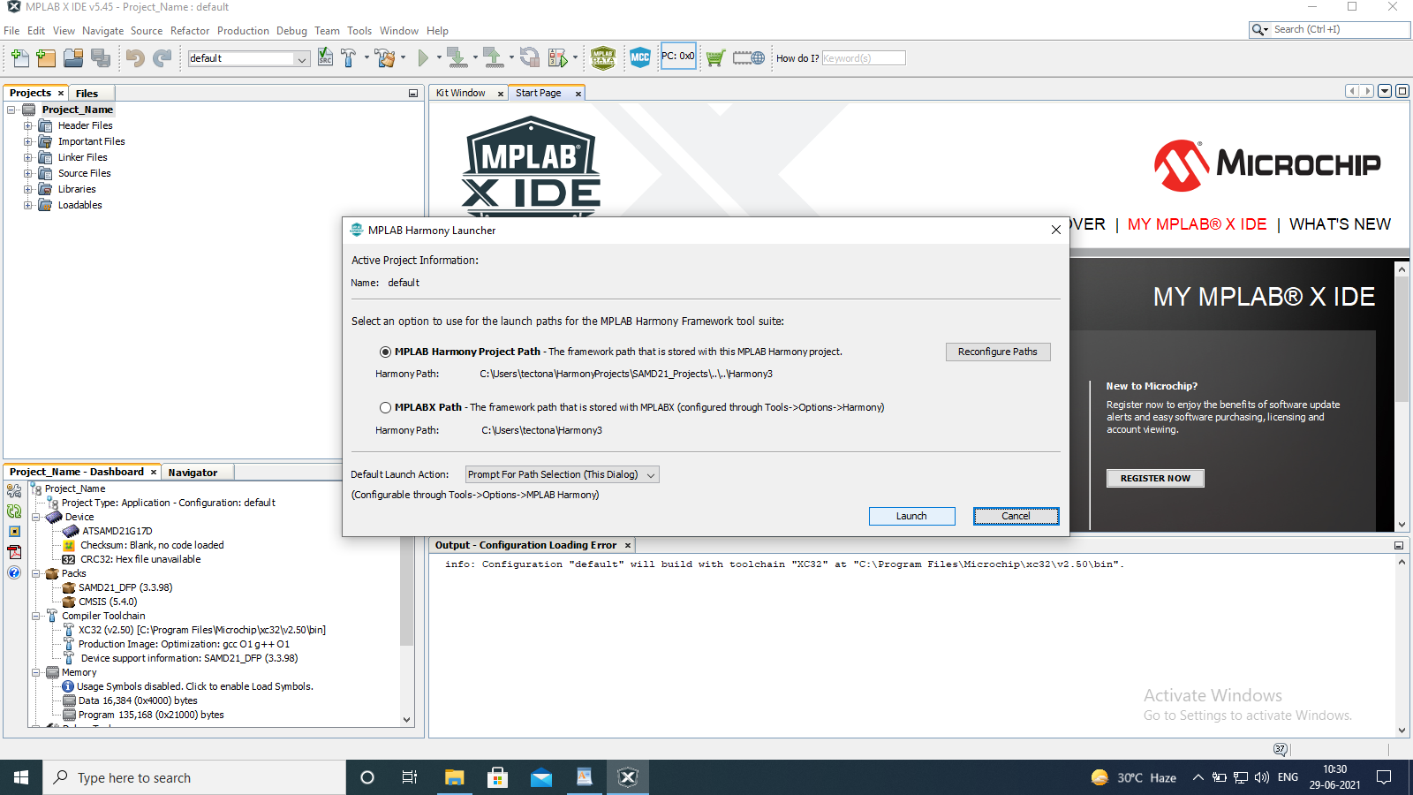

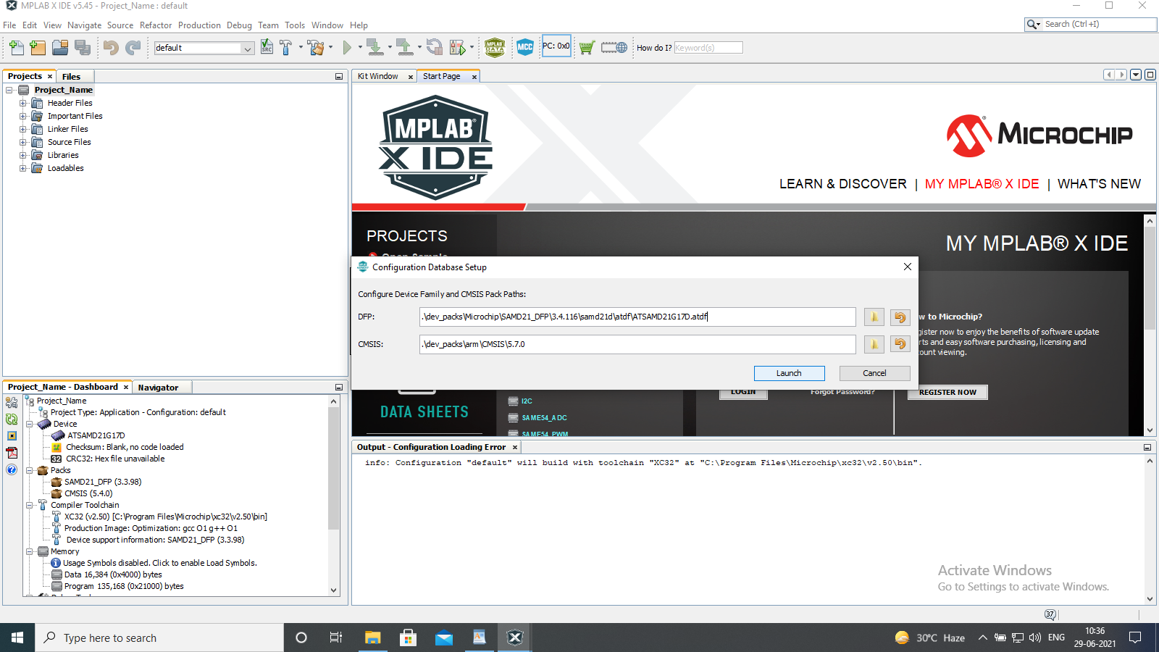

For Delay Functions:

MHC Window will open. Click on the system shown on project graph configuration options drop down to Cortex M0+ Configuration.

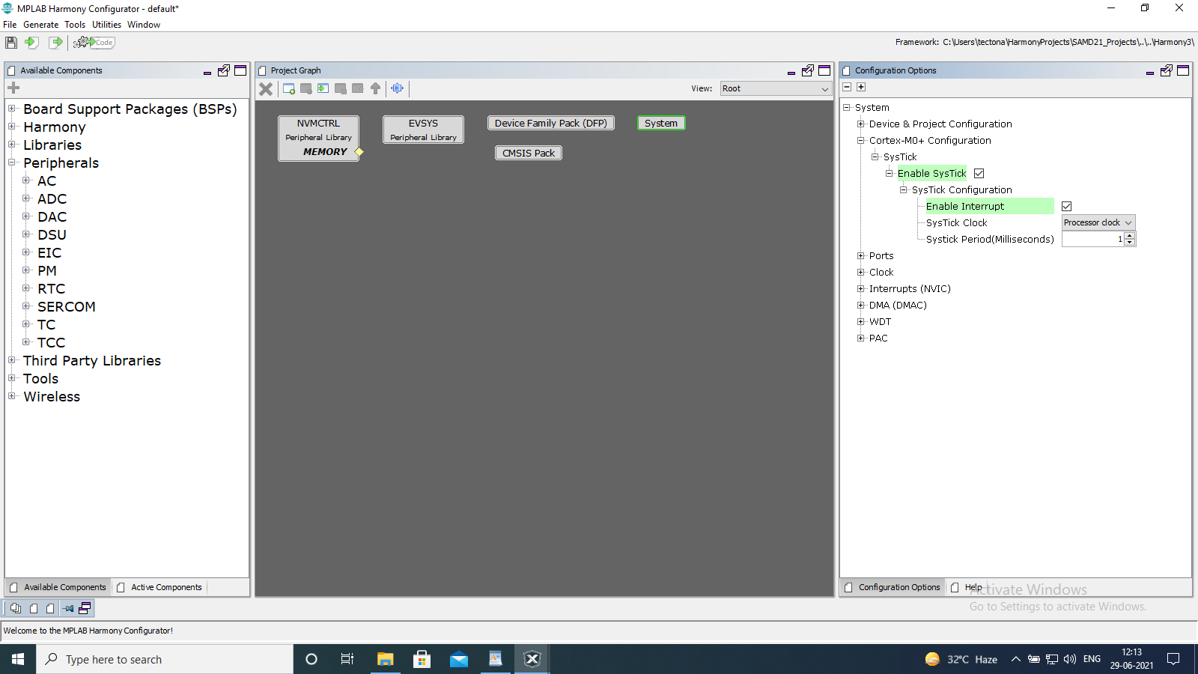

Step 9: For Clock Configuration you must go to Clock Configuration from Tools in Harmony Code Configurator which is shown as below:

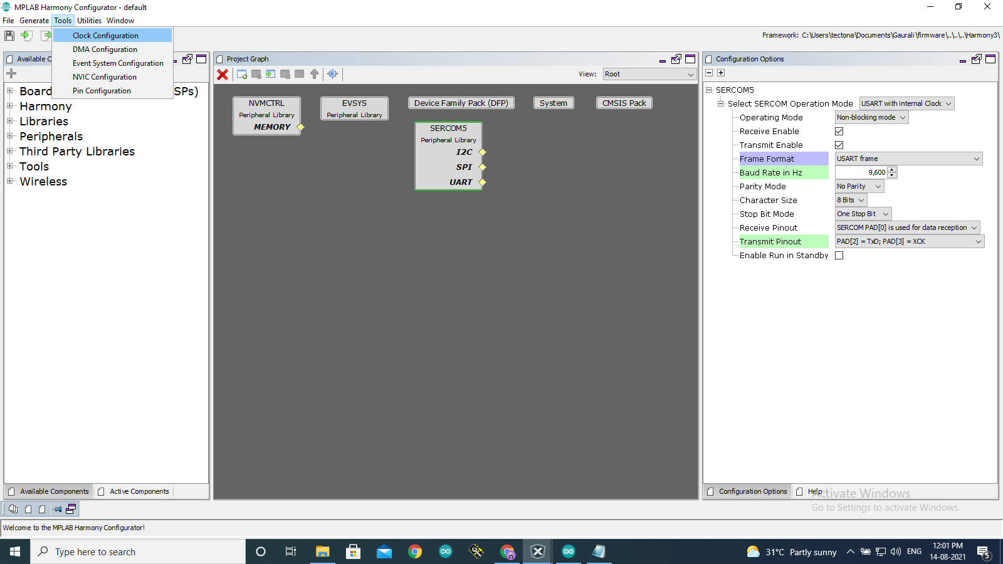

Step 10: Your Clock Configuration must not be 0. You can set the clock according to your project need.

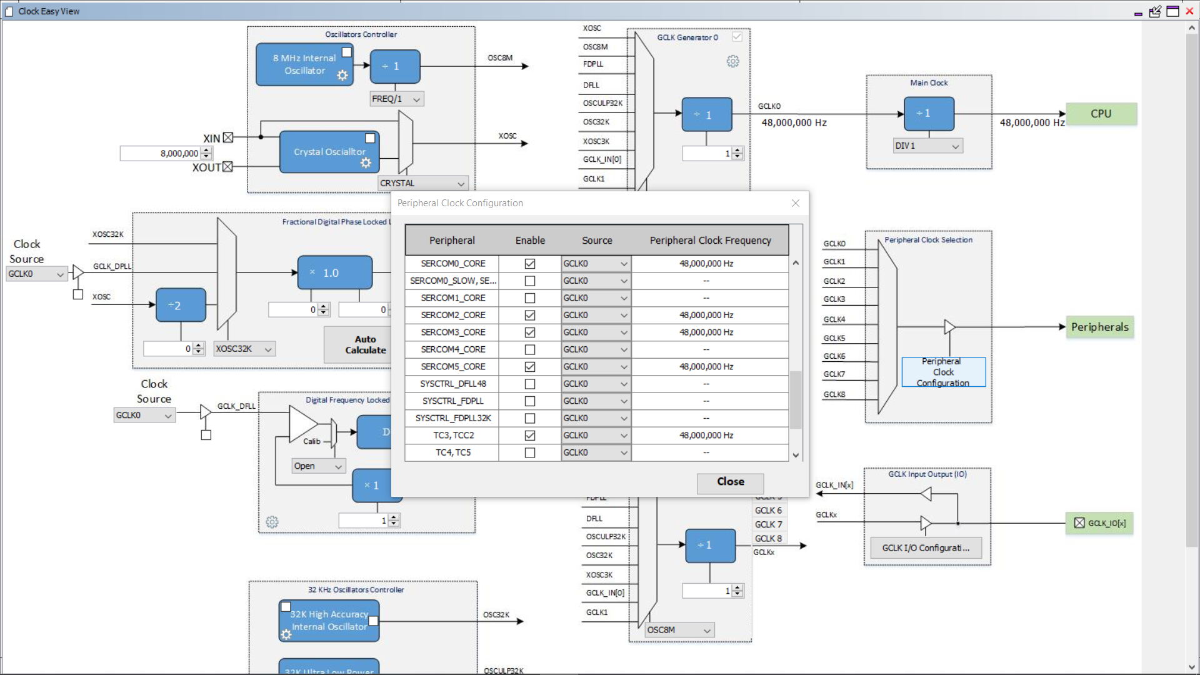

Step 11: Go to Tools -> Pin configuration

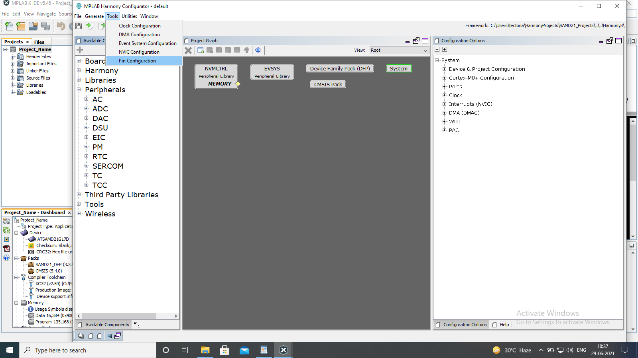

There will be 3 tabs, pin diagram, pin table and pin settings go to pin settings.

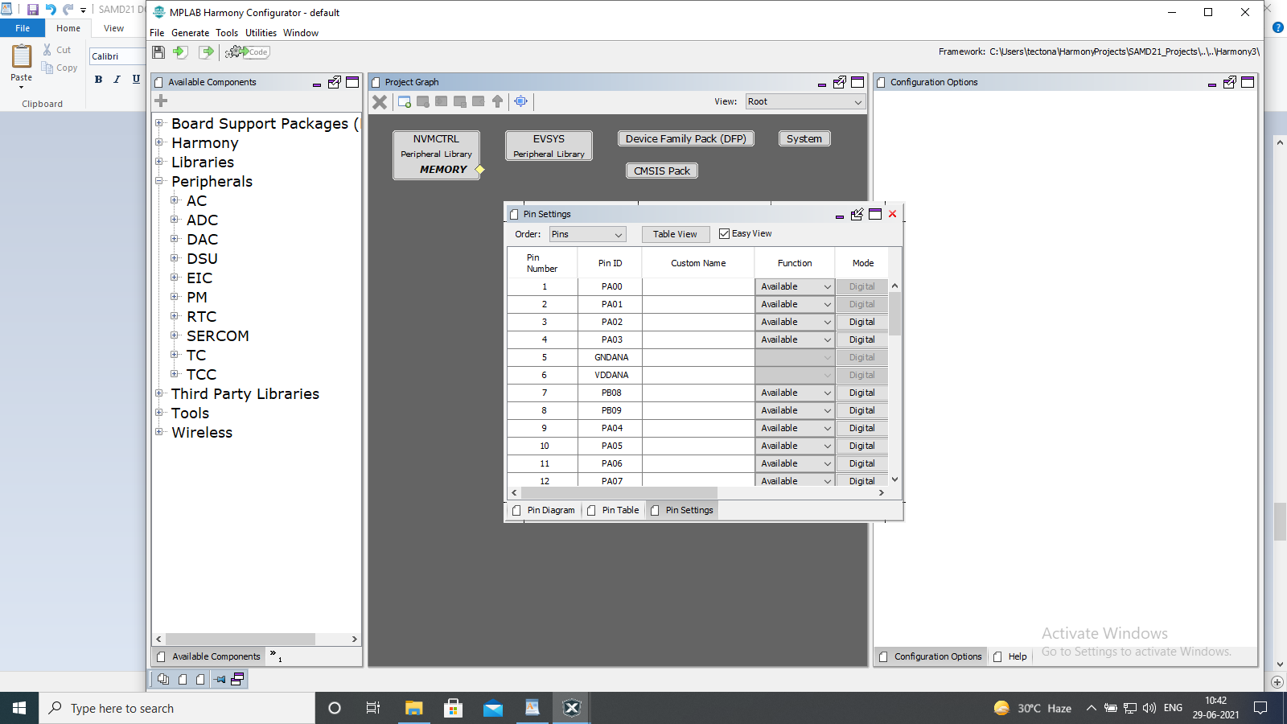

Step 12: Set pins according to your project need.

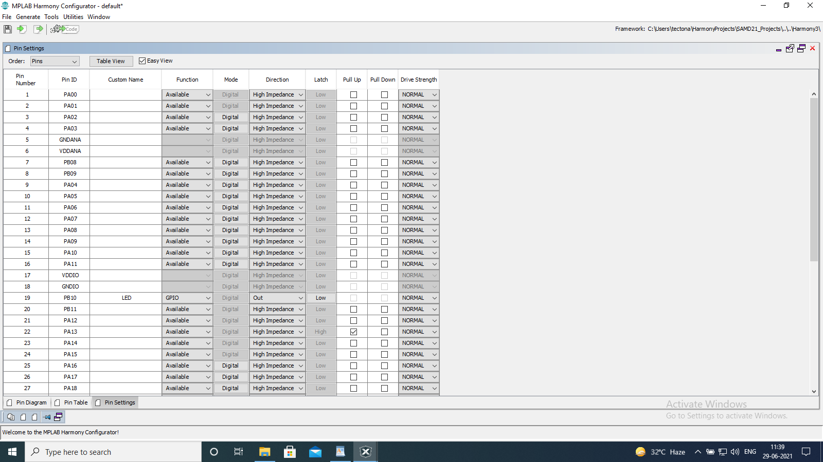

Step 13: Close and go back to Harmony Configurator